NRT FINAL REPORT TEMPLATE
Instructions: Please respond to questions below and email a completed copy to the NRT project specialist you have been working with:
Matt Cook-Contois | Nation Building | DAEF | Labour Market | mattcookcontois@nrtf.ca
Keri Fisher | DAEF | Labour Market | Food Security | kfisher@nrtf.ca
Ben Duncan | Nation Building | DAEF | Labour Market | Food Security | bduncan@nrtf.ca
Lana Plante | Food Security | Labour Market | Youth, Language, Elders, K-12 | lplante@nrtf.ca
Barb Drennan | Guardians, Stewardship and Training Initiative | guardians-navigator@nrtf.ca
In the spirit of reciprocity, we are trying to gain insight on the project successes and challenges so NRT can learn and help the next Indigenous grant recipient with a similar project. Keep in mind, we do not share personal information or matters considered confidential. If none of the names listed above are connected to your project, or if you encounter issues with submitting your report, please email or send a copy to admin@nrtf.ca

SECTION A
Organization Name:
Project Name:
Project Contact Name:
Date:
SECTION B1
Which project(s) are you reporting on?  * Check the option(s) that best applies to the project(s) you’re reporting on in this document. |  |  | 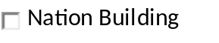        
SECTION B2
Was your Project a success or did it not go as expected?  * Check the option that best applies to your project |  |     

SECTION C
Explain the successes of your project:

* For instance - tell us how a project like this is promoting wellness, culture, economic development, language, knowledge, community participation, nation-building etc.
SECTION D
What recommendations and Challenges would you give or inform other Nations thinking about doing a similar project?

* For instance, what were the challenges, things to watch out for and things you wished you could do over etc.

SECTION E
ONLY IF APPLICABLE – Attach Report document(s) as identified in your contribution agreement.

* you can attach in a separate email if you prefer or if the file is too large to attach in this form.

To attach a document to this form.

**Place cursor in the box to the right and follow the steps on the last page of this Form.

SECTION F
ONLY IF APPLICABLE – Provide final budget as required in your contribution agreement.

*Youth, Youth Language and Elders do not have to complete the budget
** you can attach in a separate email if you prefer or attach an excel sheet using the procedures on last page of this document

Amount Received from NRT |  | $
List Expenses Below | Original Budget  Amount | $Amount  Spent
Total Expenses | $ | $

OPTIONAL – Help us share your story in pictures of your project or event.  * you can attach in a separate email or in the space provided if completing this form by computer.  - To attach a photo, click on the box in the space to the right.  * If you submit photos, we will include your project in a special draw at the end of year for a gift prize. | 

INSTRUCTIONS TO ATTACH A DOCUMENT TO THIS FORM.

Attaching or embedding another word document, power point, or a PDF document within this NRT Form is a very useful putting all information in one place. With digital documents becoming more important these days, it is a handy and helpful way to manage documents.
In Microsoft Word, place your cursor where you’d like the document to be located. Then,
1. Go to the Insert tab > Object.
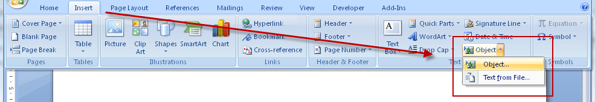
2. In the Object dialog, go to the Create from File tab
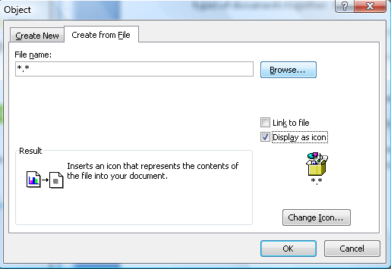
3. Click on Browse. Search and select the PDF file you wish to embed.
4. Select Display as icon and leave Link to file unchecked. You can choose to change the icon if you wish.
5. Click on OK.

